CSE370 - Database Management Report
Crypto World Bank: Relational Database Design
Course: CSE370 - Database Management
Project: Decentralized Crypto Reserve & Lending Bank
Date: 2024
Authors: Md. Bokhtiar Rahman Juboraz (20301138) • Md. Mahir Ahnaf Ahmed (20301083)

Contents
1 | Project Overview
2 | Entity-Relationship Diagram (ERD)
3 | Generalization of the Graph
4 | Database Management Summary
5 | Indexing
6 | Functional Dependencies and Normalization
7 | ER to Relational Schema Mapping
8 | Relational Integrity Constraints
9 | SQL Examples
10 | EER and User Interface

1. Project Overview
The Crypto World Bank is a decentralized lending platform with a hierarchical banking structure: World Bank → National Banks → Local Banks → Users. The database supports loan management, transaction tracking, chat systems, AI/ML security monitoring, income verification, and market data for cryptocurrency visualization.

2. Entity-Relationship Diagram (ERD)
All diagrams: [Documentation/Diagrams/CSE370](https://github.com/Yuvraajrahman/Cryto-World-Bank/tree/main/Documentation/Diagrams/CSE370)
2.1 Core System Graph
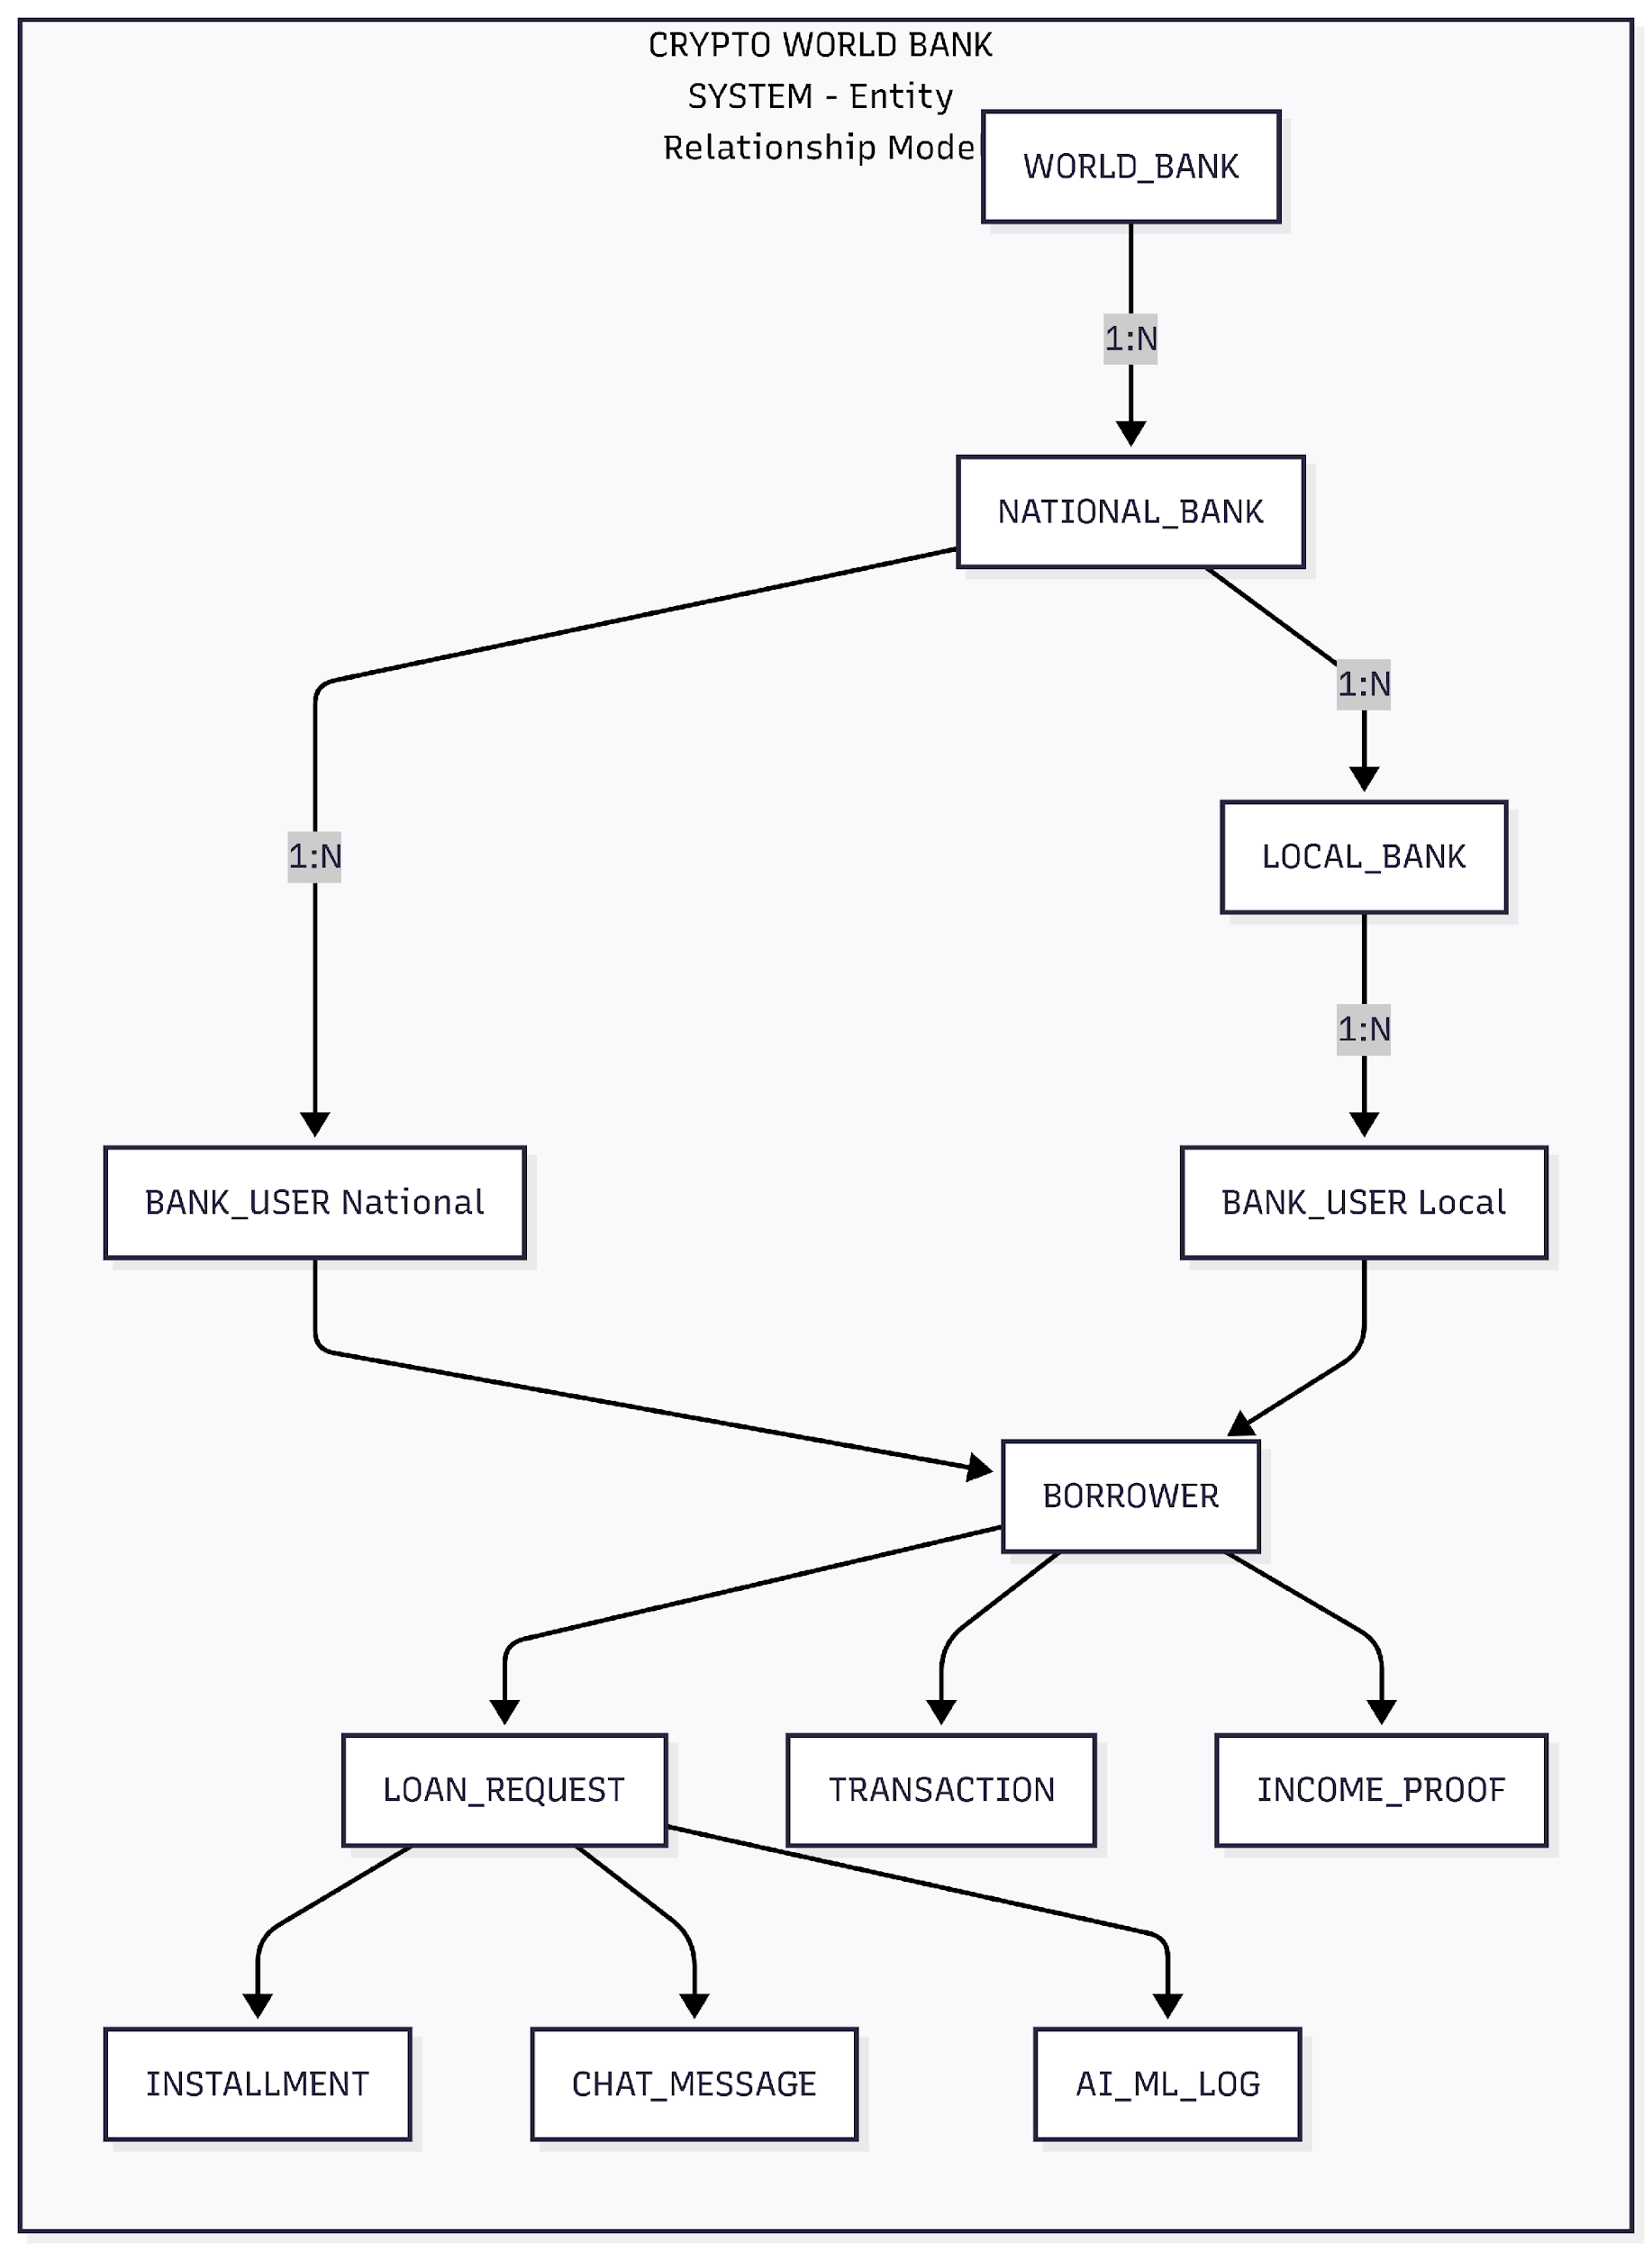
Figure 1: Crypto World Bank System – Entity Relationship Model
2.2 Entity-Relationship Diagram (ERD)
Full ERD with relational symbols and entity attributes:
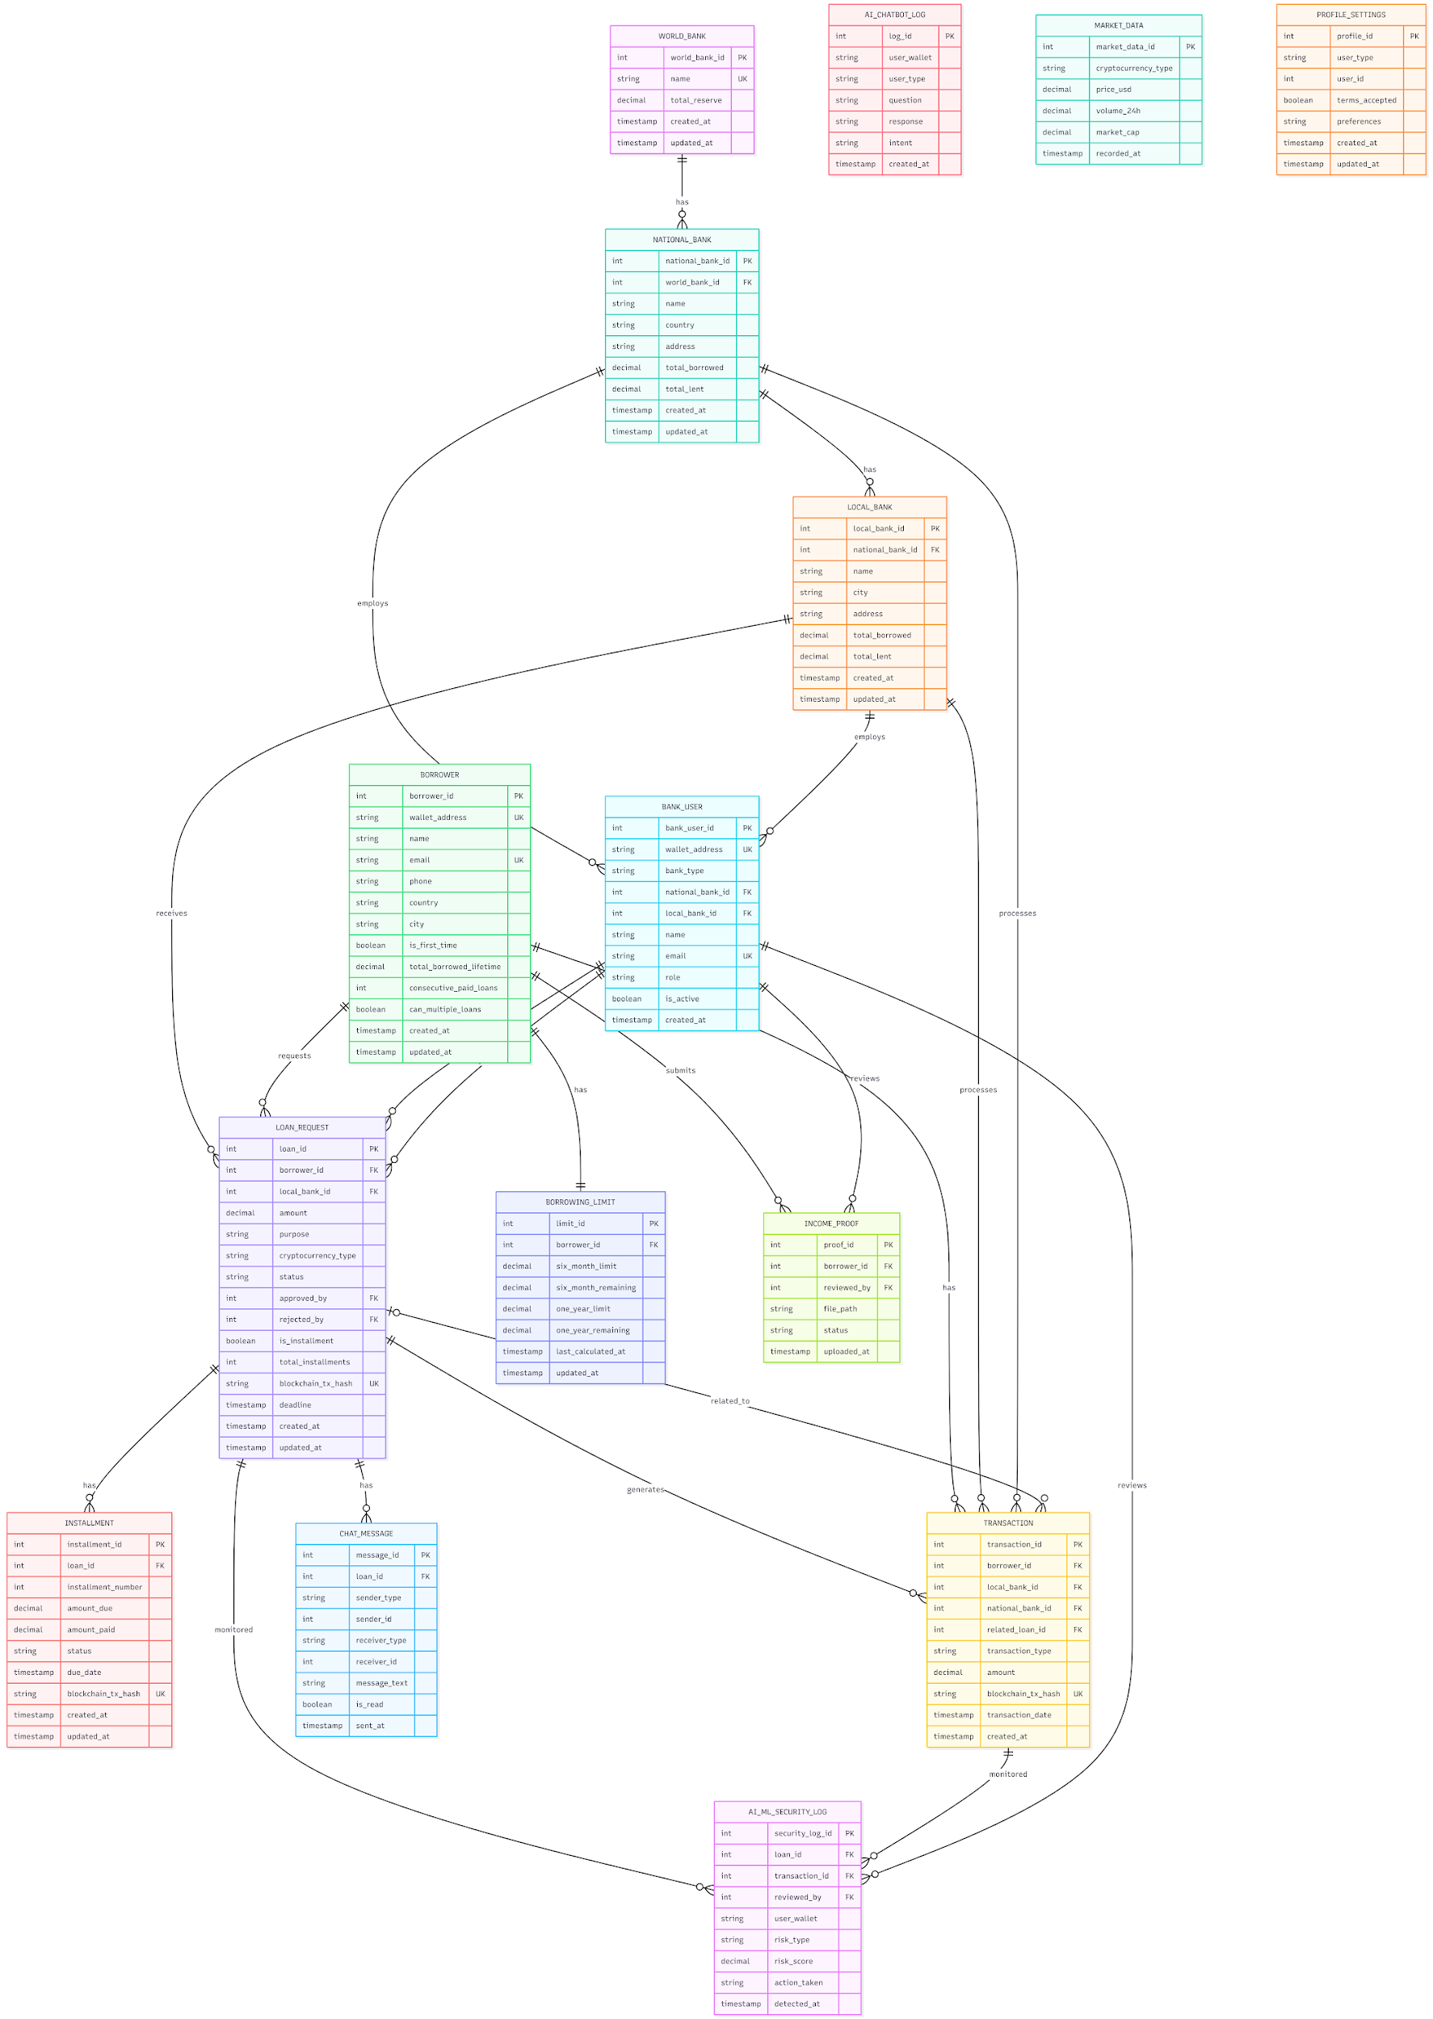
Figure 2: Entity-Relationship Diagram for Crypto World Bank database

2.3 Enhanced Entity-Relationship (EER) Diagram
The EER model extends the ER model with generalization/specialization, aggregation, weak entities, participation constraints, and cardinality to represent complex organizational data requirements. The diagram below applies schema design principles and normalization techniques.
2.3.1 EER Diagram – Relational Symbols & Notation
Symbol | Meaning
`
`
`}o--o{` | Many-to-many (M:N), partial participation
`}o--
**Double rectangle** | Weak entity (existence-dependent)
**Double diamond** | Identifying relationship
**Circle (d)** | Disjoint specialization
**Circle (o)** | Overlapping specialization

2.3.2 EER Diagram – Full Model
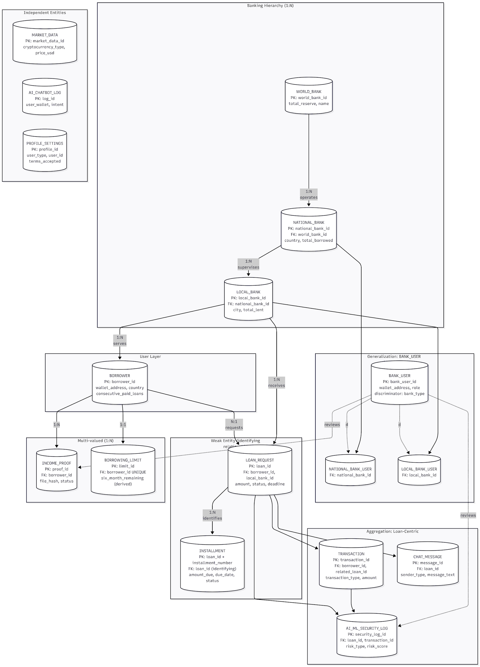
Figure 3: Enhanced Entity-Relationship Diagram – Full Model

2.3.3 EER Constructs Applied
EER Construct | Application in Crypto World Bank
**Generalization (disjoint)** | BANK_USER → NATIONAL_BANK_USER, LOCAL_BANK_USER (discriminator: `bank_type`; mutually exclusive FKs)
**Weak entity** | INSTALLMENT (existence-dependent on LOAN_REQUEST; partial key `installment_number`; identifying relationship)
**Aggregation** | LOAN_REQUEST aggregates BORROWER + LOCAL_BANK; TRANSACTION, CHAT_MESSAGE, AI_ML_SECURITY_LOG are components
**Multi-valued attribute** | INCOME_PROOF (BORROWER can have multiple proofs) → separate entity
**Derived attribute** | `six_month_remaining`, `one_year_remaining` in BORROWING_LIMIT (computed from TRANSACTION)
**Composite key** | INSTALLMENT: (`loan_id`, `installment_number`)
**Participation** | BORROWER total in LOAN_REQUEST (must request to exist); INSTALLMENT total in LOAN_REQUEST (loan must have installments if `is_installment=TRUE`)
**Cardinality** | 1:1 (BORROWER–BORROWING_LIMIT), 1:N (hierarchy, loan–installment), N:1 (loan–borrower, loan–bank)

2.3.4 Normalization in EER Context
• 1NF: All attributes atomic; no repeating groups (e.g., INCOME_PROOF as separate table).
• 2NF: No partial dependencies; INSTALLMENT PK is full (`loan_id`, `installment_number`).
• 3NF: No transitive dependencies; `total_borrowed` in banks is denormalized for performance but could be derived.
• BCNF: All determinants are candidate keys; CHECK constraint on BANK_USER enforces disjoint specialization.

3. Generalization of the Graph
3.1 Structural Overview
The database follows a hierarchical and relational design:
Layer | Structure | Description
**Banking Hierarchy** | 1:N cascading | World Bank → National Bank → Local Bank
**User Layer** | Bank Users + Borrowers | Bank staff (approvers/viewers) and end-user borrowers
**Lending Core** | Loan-centric | Loan requests, installments, transactions
**Supporting Entities** | Independent/auxiliary | Income proof, chat, AI logs, market data, profiles

3.2 Relationship Categories
Category | Relationships
**Hierarchical Banking** | WORLD_BANK (1) → NATIONAL_BANK (N) → LOCAL_BANK (N)
**User Assignment** | NATIONAL_BANK / LOCAL_BANK (1) → BANK_USER (N)
**Lending Flow** | BORROWER (N) → LOAN_REQUEST (N) ← LOCAL_BANK (1)
**Transaction Tracking** | LOAN_REQUEST (1) → INSTALLMENT (N), TRANSACTION (N)
**Communication** | LOAN_REQUEST (1) → CHAT_MESSAGE (N)
**Security & AI** | LOAN_REQUEST, TRANSACTION → AI_ML_SECURITY_LOG (N)

3.3 Entity Summary
Entity | Role
WORLD_BANK | Top-level reserve holder
NATIONAL_BANK | Country-level banks
LOCAL_BANK | City-level banks
BANK_USER | Bank staff (approve/reject loans)
BORROWER | End-users requesting loans
LOAN_REQUEST | Loan applications and lifecycle
INSTALLMENT | Installment payment records
TRANSACTION | Financial transactions
BORROWING_LIMIT | Limits per borrower
INCOME_PROOF | Income verification documents
CHAT_MESSAGE | Borrower–bank chat
AI_CHATBOT_LOG | AI chatbot interactions
AI_ML_SECURITY_LOG | Security/ML monitoring
MARKET_DATA | Cryptocurrency prices
PROFILE_SETTINGS | User profiles and terms

4. Database Management Summary
• Normalization: 3NF (Third Normal Form)
• Purpose: Supports hierarchical banking, loan lifecycle, installments, borrowing limits, chat, AI/ML security, income verification, and market data
• Key Design: Referential integrity via foreign keys; indexes for query optimization; partitioning for scalability (transactions, logs, market data)

5. Indexing
5.1 Indexing
The schema uses B-tree indexes (default in MySQL/PostgreSQL) for efficient retrieval:
Table | Index | Purpose
LOAN_REQUEST | `idx_status_borrower`, `idx_status_bank`, `idx_deadline` | Filter pending loans, lookup by borrower/bank
TRANSACTION | `idx_type_date`, `idx_borrower_date`, `idx_date` | Borrowing limit queries (6mo/1yr windows)
BORROWER | `idx_wallet`, `idx_location` | Wallet lookup, location-based queries
CHAT_MESSAGE | `idx_loan_sent`, `idx_sender`, `idx_receiver` | Chat history, unread counts

B-tree is chosen for range queries (e.g., transactions in last 6 months); hash indexes would suit only exact-match lookups.

6. Functional Dependencies and Normalization
6.1 Functional Dependencies (Sample)
Relation | FD | Notes
LOAN_REQUEST | `loan_id` → all attributes | PK determines row
LOAN_REQUEST | `borrower_id`, `local_bank_id` → `status`, `amount`, ... | One request per borrower per bank
BORROWING_LIMIT | `borrower_id` → `six_month_limit`, `one_year_limit`, ... | 1:1 with BORROWER

6.2 Normalization Steps
• 1NF: All attributes atomic; no repeating groups.
• 2NF: No partial dependencies; non-key attributes depend on full PK (e.g., INSTALLMENT depends on `loan_id` + `installment_number`).
• 3NF: No transitive dependencies; e.g., `total_borrowed` in LOCAL_BANK is derived, not stored redundantly from TRANSACTION.

7. ER to Relational Schema Mapping
ER Construct | Mapping
Entity | Table (e.g., BORROWER → BORROWER table)
1:N relationship | FK in "many" side (e.g., LOAN_REQUEST has `borrower_id`, `local_bank_id`)
1:1 relationship | FK in either table (e.g., BORROWING_LIMIT has `borrower_id` UNIQUE)
Weak entity (INSTALLMENT) | PK includes parent FK (`loan_id` + `installment_number`)
Multi-valued attribute | Separate table (e.g., INCOME_PROOF for multiple proofs per borrower)

8. Relational Integrity Constraints
Constraint | Examples
**Primary Key** | `world_bank_id`, `loan_id`, `borrower_id`, etc.
**Foreign Key** | `local_bank_id` in LOAN_REQUEST references LOCAL_BANK
**UNIQUE** | `wallet_address` in BORROWER, `blockchain_tx_hash` in LOAN_REQUEST
**CHECK** | BANK_USER: `(bank_type='national' AND national_bank_id IS NOT NULL) OR (bank_type='local' AND local_bank_id IS NOT NULL)`
**NOT NULL** | Core attributes (name, wallet_address, status)

9. SQL Examples
Representative queries used by the application:
DDL (create table): See `backend/src/database/schema.sql`.
DML – Insert loan request:
INSERT INTO LOAN_REQUEST (borrower_id, local_bank_id, amount, purpose, status)
VALUES (?, ?, ?, ?, 'pending');
Query – Pending loans for a bank:
SELECT lr.*, b.name, b.wallet_address
FROM LOAN_REQUEST lr
JOIN BORROWER b ON lr.borrower_id = b.borrower_id
WHERE lr.local_bank_id = ? AND lr.status = 'pending';
Query – Borrowing limit (6-month window):
SELECT COALESCE(SUM(amount), 0) AS borrowed_6mo
FROM TRANSACTION
WHERE borrower_id = ? AND transaction_type = 'loan_approved'
AND transaction_date >= DATE_SUB(NOW(), INTERVAL 6 MONTH);

10. EER and User Interface
10.1 EER Generalization
BANK_USER generalizes National Bank users and Local Bank users via `bank_type` + conditional FKs (`national_bank_id` or `local_bank_id`). This is modeled as a single table with a discriminator (table-per-type would split into NATIONAL_BANK_USER and LOCAL_BANK_USER).
10.2 Database User Interface
The React frontend serves as the user interface for the database: dashboard, loan forms, chat, profile pages, and admin views all read/write via the backend API, which executes SQL against PostgreSQL. See CSE471 for UI design and CSE470 for architecture.

Document Version: 1.3
Course: CSE370 - Database Management
Changelog (v1.3): Replaced all Mermaid diagrams with embedded PNG images from [Documentation/Diagrams/CSE370](https://github.com/Yuvraajrahman/Cryto-World-Bank/tree/main/Documentation/Diagrams/CSE370).

